* 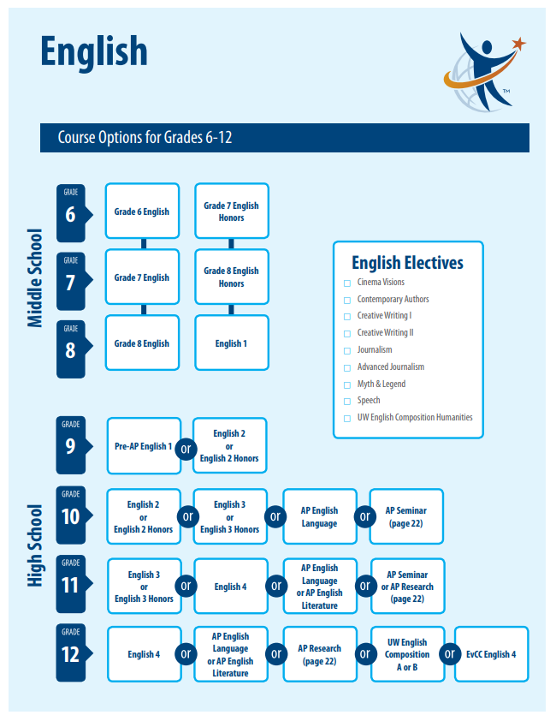Four credits of English are required for high school graduation, and the course options for each grade level in high school are shown above. If students successfully pass English 1 in 8th grade they must request that this course and credit be added to their high school transcript in order for that class to count as fulfilling one of the four required high school English courses.
* Students in the middle school honors pathway can take English 2 or English 2 Honors in grade 9.
* Students who took Grade 8 English as eighth graders will be prepared for the rigorous Pre-AP English 1 course in 9th grade and, by their junior year, will be ready for the AP English course sequence.

**Student Success in English Advanced Pathway Courses**

**English advanced pathways courses** provide a higher level of academic demand, an accelerated pace with minimal practice, and greater depth and complexity, compared to core courses. Students in these courses are expected to meet the increased work and study expectations and to put in the extra time and work needed outside of school to keep up with the faster pace of the course and the amount of independent reading expected. In addition, students are expected to perform at standard/above standard in class.

**Academic Indicators for Success**

Students who are successful in English advanced pathway courses have demonstrated the indicators for academic success as indicated below:

* **Academic performance** demonstrating a high level of proficiency in English Language Arts (above grade level proficiency in elementary Reading and Writing)
* **Well-developed reading, writing, speaking, and listening skills** demonstrated in prior performance in classes and on classroom-based assessments
* **Demonstrated interest** in reading independently and analyzing and responding to texts

**Other Important Indicators for Success**

Students who are successful in in English advanced pathway courses have demonstrated other important indicators for academic success listed below. Successful students:

* **Demonstrate intellectual engagement**

They demonstrate a high level of interest, intellectual engagement, and a strong desire to be challenged in English Language Arts

* **Take responsibility for their learning**

They are highly self-motivated, have the desire to excel in their courses, take responsibility for their own learning, strive to meet a high level of academic demand and an accelerated pace of learning, attend class regularly, complete assignments on time, and recognize that effort is an important component of success.

* **Persevere with complex tasks**

They successfully complete tasks that require time, thought, and implementation of multiple steps, concepts, or techniques.

* **Are flexible, resourceful thinkers**

They examine and learn from errors, try different approaches when needed, revise their work throughout the learning process, and seek help and access resources when needed.